

Project Acronym | RAISE
Project Name | Research Analysis Identifier SystEm
Project Number | 101058479
Topic | HORIZON-INFRA-2021-EOSC-01-04
Type of Action | HORIZON Research and Innovation Actions
Granting Authority | European Research Executive Agency
Project starting date | 1 October 2022
Project end date | 31 January 2026
Project duration | 40 months

D3.1 RAI Cloud services' specifications
(Version 3.0, 29/03/2024)

Deliverable Number | D3.1
Deliverable Name | RAI Cloud services' specifications
Work Package No | WP3
Due Date (month) | 18
Submission Date | 18
Lead Beneficiary | VICOM
Version | 3.0
Status | Final
Author name(s) | Mikel Hernandez (VICOM)
Contributor(s) | Nikolaos Nikolaidis (UoM), Nikolaos Katertsidis (UoWM), Ilias Romas (INTRA), Dimosthenis Natsos (CLPT), Yannis Kouris (TCR), Ilektra Makridou (AUTH), Gorka Epelde (VICOM)
Reviewer(s) | Tassos Pantazidis (INNOV-ACTS) | Ioanna Drigkopoulou (INTRA)
Approved by | Evdokimos Konstantinidis, Project Coordinator (AUTH)
Keywords | Architecture, PID, distributed crowdsourced data processing system
Type | R – Document, report
Dissemination level | PU - Public

The RAISE Consortium consists of:
Participant # | Participant organisation name | Short Name | Country
1 COO | ARISTOTELIO PANEPISTIMIO THESSALONIKIS | AUTH | EL
2 BEN | FUNDACION CENTRO DE TECNOLOGIAS DE INTERACCION VISUAL Y COMUNICACIONES VICOMTECH | VICOM | ES
3 ΒΕΝ | NETCOMPANY-INTRASOFT SA | INTRA | LU
4 BEN | PANEPISTIMIO DYTIKIS MAKEDONIAS | UOWM | EL
5 BEN | UNIVERSITY OF MACEDONIA | UOM | EL
6 BEN | TECREANDO BV | TECREANDO | NL
7 BEN | WITA SRL | WITA SRL | IT
8 BEN | ETHNIKO KENTRO EREVNAS KAI TECHNOLOGIKIS ANAPTYXIS | CERTH | EL
9 BEN | INNOV-ACTS LIMITED | INNOVACTS | CY
10 BEN | VILABS (CY) LTD | VILABS | CY
11 BEN | KYKLIKI VELTISTOPOIISI IKE | Cyclopt PC | EL
12 BEN | KAROLINSKA INSTITUTET | KI | SE
13 BEN | ATHINA-EREVNITIKO KENTRO KAINOTOMIAS STIS TECHNOLOGIES TIS PLIROFORIAS, TON EPIKOINONION KAI TIS GNOSIS | ATHENA | EL
14 BEN | AINIGMA TECHNOLOGIES | AINIGMA | BE
15 BEN | UNIVERSITEIT HASSELT | UHASSELT | BE
16 BEN | OPENAIRE AMKE | OPENAIRE | EL
17 BEN | CENTRO EUROPEO DI FORMAZIONE E RICERCA IN INGEGNERIA SISMICA | EUCENTRE | IT
18 BEN | ENVE.X SINGLE MEMBER PC | ENVE.X | EL
19 AP | UNIVERSITY OF SOUTHAMPTON | SOTON | UK
20 AP | ROYAL INSTITUTION FOR THE ADVANCEMENT OF LEARNING MCGILL UNIVERSITY | McGill | CA

Revision history
Version | Date | Modified by | Comments
0.1 | 06/02/2024 | Mikel Hernandez (VICOM) | Table of contents, executive summary, architecture figure and assigned sections to partners.
0.2 | 12/02/2024 | Mikel Hernandez (VICOM) | First draft of Section 1
1.0 | 20/02/2024 | Mikel Hernandez (VICOM) | Added content to technical requirements and RAISE service architecture sections.
1.1 | 26/02/2024 | Mikel Hernandez (VICOM),  Nikolaos Nikolaidis (UoM),  Nikolaos Katertsidis (UoWM) | Added content to RAISE service architecture sections, user use cases workflows, prototype development and deployment and conclusion.
1.2 | 28/02/2024 | Mikel Hernandez (VICOM),  Dimosthenis Natsos (CLPT),  Ilias Romas (INTRA) | Added information about current prototype limitations and future work, code maintainability and security analysis, and RAI Central Hub.
1.3 | 12/03/2024 | Yannis Kouris (TCR),  Ilektra Makridou (AUTH),  Mikel Hernandez (VICOM) | Added information about reproducible ML, data version, RAI finder, popular dataset preservation and results repository modules, and technical specifications of the RCN deployed in AUTH.
2.0 | 26/03/2024 | Mikel Hernandez (VICOM),  Ilektra Makridou (AUTH),  Gorka Epelde (VICOM) | Incorporated reviewers’ suggestions and minor adjustments from AUTH side.
3.0 | 29/03/2024 | Eleni Bolieraki (AUTH), Evdokimos Konstantinidis (AUTH) | Corrected formatting, approved additions.

Table of Contents
Table of Contents 5
List of Figures 6
List of Tables 6
Abbreviations 7
Executive summary 8
1 RAISE Service Overview 9
1.1 Description of the RAISE service 9
1.2 RAISE user use cases 9
1.3 RAISE service agents and technical requirements 10
1.3.1 Research Community 11
1.3.2 RAI Central Hub 11
1.3.3 RAI Certified Node(s) 13
1.3.4 RAI Registration Service 14
2 RAISE service architecture 16
2.1 Overall RAISE service architecture 16
2.2 RAI Central Hub 17
2.2.1 RAISE fair catalogue and portal for data discovery 17
2.2.2 RAI finder service 18
2.2.3 Complex script execution scheduler 18
2.2.4 Reproducible ML 18
2.2.5 Code maintainability and security analysis 18
2.2.5.1 Static code analysis and code quality assessment 19
2.2.5.2 Code security and dynamic analysis 19
2.2.6 Popular dataset preservation and multi-tenant RAI node 21
2.2.7 Fair publishing of RAIs and results repository 21
2.2.8 RAI nodes status monitoring 21
2.3 RAI Certified Node(s) 21
2.4 RAI registration service 23
2.5 Plagiarism checker 24
2.6 RAISE Software Development Kit 24
2.7 Federated authentication and data access 24
3 RAISE user use cases workflows 25
3.1 Make data accessible 25
3.2 Find datasets and get access for processing 26
3.3 Prepare processing scripts on synthetic data 27
3.4 Upload and remotely run processing scripts 28
4 Prototype development and deployment 30
4.1 Deployed RAI Certified Nodes 30
4.1.1 RAI Certified Node deployed in VICOM 30
4.1.2 RAI Certified Node deployed in UOWM 30
4.1.3 RAI Certified Node deployed in AUTH 31
4.2 Limitations of the actual prototype and future prototypes 32
5 Conclusion 33
6 References 34

List of Figures
Figure 1: User use cases of the RAISE service 9
Figure 2: RAISE network topology and resources 11
Figure 3: RAISE service architecture 16
Figure 4: RAISE FAIR catalogue and portal architecture 17
Figure 5: Static/Dynamic security and Performance analyzers’ architecture 20
Figure 6: Static/Dynamic security and Performance analyzers’ workflow 20
Figure 7: Architecture of the RAI Certified Node(s) 22
Figure 8: Architecture of the RAI registration service 23
Figure 10: Defined workflow for the Make Data Accessible use case 25
Figure 11: Defined workflow for finding available datasets 26
Figure 12: Defined workflow for accessing dataset visualizations and descriptive statistics 27
Figure 13: Defined workflow for preparing processing scripts on shareable datasets uploaded by researchers 27
Figure 14: Defined workflow for preparing processing scripts on synthetic datasets generated by the RCN 28
Figure 15: Defined workflow for uploading processing scripts 28
Figure 16: Defined workflow for running processing scripts 29
Figure 17: Services of the GRNET 31

List of Tables
Table 1: Requirements and technologies of the RAI Central Hub 12
Table 2: Requirements and technologies of the RAI Certified Nodes 13
Table 3: Requirements and technologies of the RAI Certified Nodes 14

Abbreviations
EC | European Commission
EU | European Union
GA | Grant Agreement
REA | European Research Executive Agency
WP | Work Package
PB | Plenary Board or General Assembly
RAI | Research Analysis Identifier
IPR | Intellectual Property Rights
ICT | Information and Communication Technologies
ML | Machine Learning
API | Application Programming Interface
SDK | Software Development Kit
RAI | Research Analysis Identifier
DOI | Digital Object Identifier
RCN | RAI Certified Node
RCH | RAI Central Hub
ML | Machine Learning
SSO | Single-Sign On
GRNET | Greek Research and Technology Network
FAIR | Findable, Accessible, Interoperable and Reusable
SMPC | Secure Multi Party Computation
DP | Differential Privacy

Executive summary
This deliverable, which is of report nature as specified in the GA, aims to present the RAISE service specification and federated architecture designed to facilitate the communication and delivery of the ICT tools developed in WP3 and WP4 that compose the RAISE system.
The primary goal of the designed architecture is to effectively share and manage data across RAI nodes during experiment processing while adhering to privacy, ethics and IPR legislation and policies established by the respective research entities providing processing infrastructure.
The information presented in this deliverable mainly resulted from Task 2.4 (Service architecture evolution and federated authentication), although its completion relies on contributions from other tasks within WP3 and WP4.
The structure of the document is as follows. First, the RAISE service is introduced and explained along with its user and technical requirements (Section ‎1). Then, the architecture of the RAISE service is described, and the interactions between the modules that compose it are detailed (Section ‎2). Next, the designed and developed workflows and solutions for the RAISE use cases are presented (Section ‎3). Finally, some concluding remarks for this deliverable are provided in Section ‎5.
NOTE: The actual deliverable presents the current design of the RAISE service architecture and some explanations of its current developments. Future integrations are planned to improve the architecture with specified functionalities that are being developed according to the initial planning of the project. While adjustments may be made to the architecture design according to specifications outlined in the GA, no significant changes regarding the general architecture are anticipated. However, if necessary, relevant content within this document will be updated, though such updates are not initially planned.

RAISE Service Overview
The RAISE service architecture has been designed to effectively share and manage data across different research entities during experiment processing from external researchers while adhering to privacy, ethics, IPR legislation, and policies established by the respective research entities providing processing infrastructure. This section presents the RAISE service, the user use cases, and the technical requirements.

Description of the RAISE service
RAISE proposed to provide the infrastructure for a distributed crowdsourced data processing system, moving from open data to data open for processing ensuring FAIR principles. The service provides the mechanisms for sending the algorithm to the data instead of sending the data to the algorithm to do so. The real value of open data for the research community is not to access them but to process them as conveniently as possible to reduce time-to-result and increase productivity.
The vision of the system is that the EOSC Web of FAIR Data and Services for Science is an open, fair and reliable Research Community where every researcher will be accredited for their work, and all research data will be equally accessible for processing without violating data protection regulations. With this objective, the Research Analysis Identifier (RAI) is introduced. The RAI aims to become an PID for reliable research experiment results referencing, which includes information on the experiment data, algorithm or processing script, authorship, timing and produced results encrypted and stored within a blockchain network. In a few words, it is aimed to become the DOI of the analysis of scientific results.

RAISE user use cases
This subsection explains the user use cases of the RAISE system that have guided the technical requirements definition and the design of the RAISE service architecture. These user use cases are shown in Figure 1 and have been defined and compiled after some workshops and dissemination activities developed for the scientific community and internal discussions between technical partners.
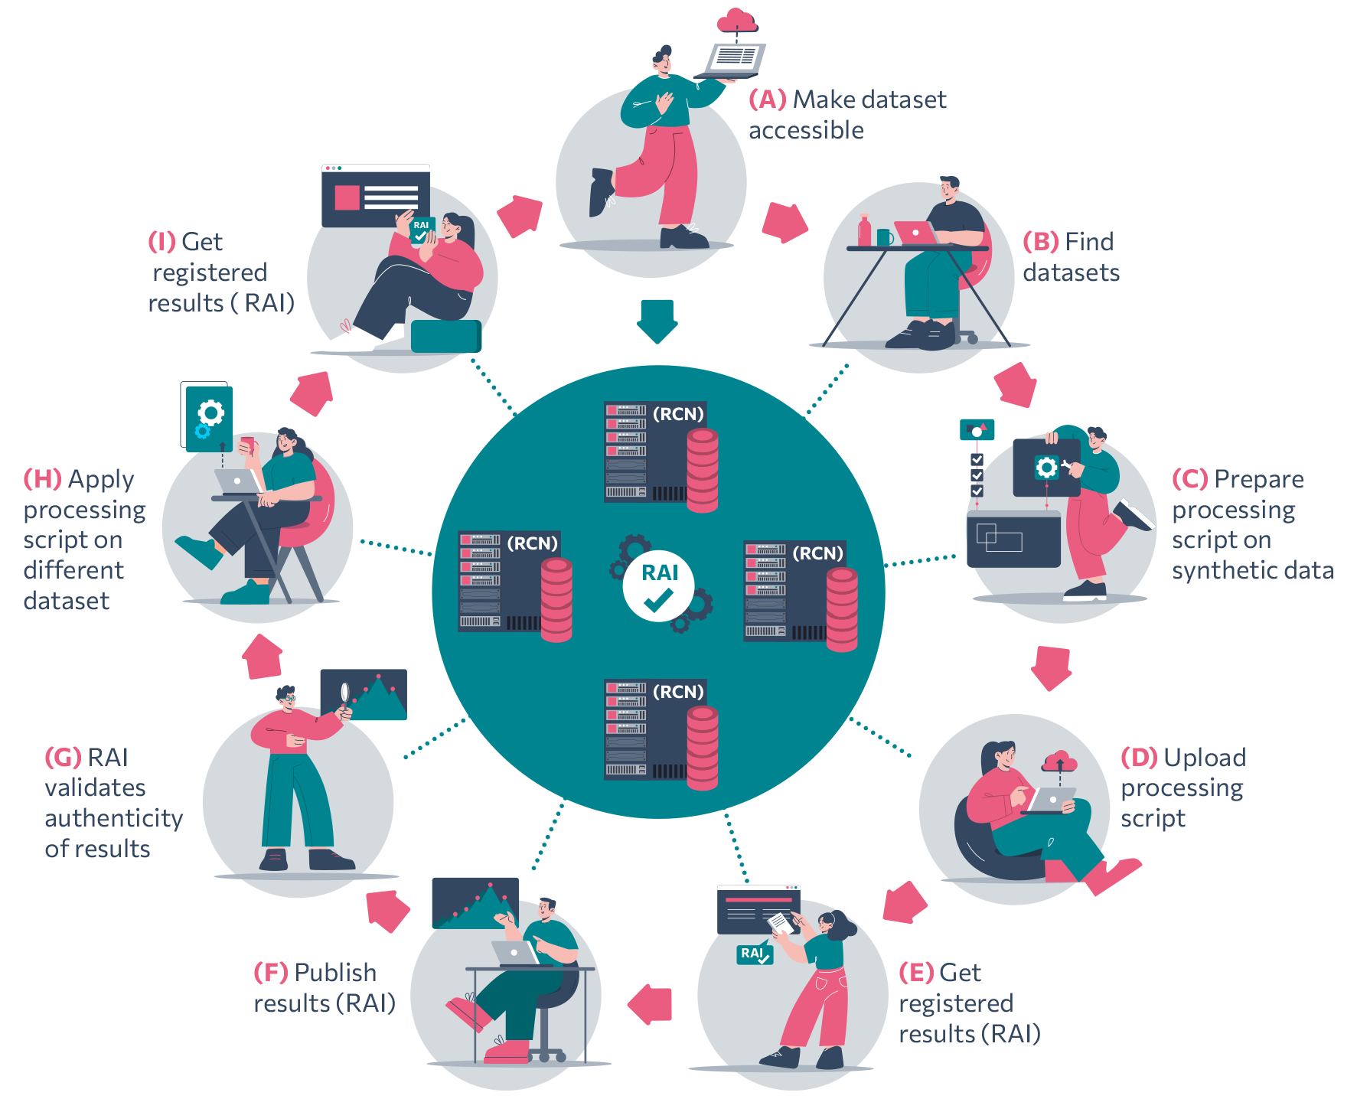
Figure 1: User use cases of the RAISE service
Each of the identified user use cases represents a distinct interaction or functionality that users can accomplish while using the RAISE service to perform specific tasks related to data processing, processing scripts execution and experiments registration. Next, the user use cases defined and shown in Figure 1 are listed and described:
- (A) Make dataset accessible: researchers can make their data available to the research community via the RAISE research ecosystem. They can upload their data on their own or any other RAI Certified Node (RCN), a trustworthy crowdsourced network offering data storing and processing resources.
- (B) Find datasets: any researcher can look for datasets that meet their needs for their given research question and projects. The RAI Finder Service enables them to find and access registered experiment results, including the dataset and the processing algorithm’s information, or even the actual assets if the researcher has opted-in for open experiment sharing.
- (C) Processing script on synthetic data: the RAI Synthetic Data Generator allows the researchers to develop processing scripts by getting access to sample datasets, small scale datasets or synthetic datasets which mock real datasets in order to protect any sensitive or personal data.
- (D) Upload processing script: researchers can upload processing scripts or algorithms which will run on the remotely hosted datasets, running the algorithm without allowing the researcher to download or access them directly.
- (E) Get registered results: the processing scripts or algorithms and dataset pair are registered and receive the RAI persistent identifier. When the requested experiment computation is completed, the RCN registers the results to a blockchain network through the RAI Registration Service, receiving an RAI as the outcome of the registration process.
- (F) Publish results: the results of the registration process are published and available for researchers through the RAI Central Hub (RCH). Any request arriving at the RCH for processing a dataset or getting access to a sample synthetic dataset will be addressed by the RCH to the corresponding RCN.
- (G) RAI validates the authenticity of results: any researcher can validate the registered results, which enables experiment results' authenticity and veracity validation. The dataset plagiarism identification and dataset proof-of-origin services add an extra layer of security by identifying similar datasets.
- (H) Apply processing script on different datasets: the uploaded processing scripts or algorithms can be used on different datasets and contexts (scientific publications, patent submission, contract negotiation, etc.) in order to compare results.
- (F) Get registered results: the datasets are now available in RAI Cloud to be shared and processed efficiently by the research communities interested as conveniently as possible in order to reduce time-to-result and increase productivity.

RAISE service agents and technical requirements
The RAISE service has been divided into three main agents (Research Community, RCNs, RAI Central Hub and RAI Registration Service) to facilitate the scalability and deployment of the service. Each agent is specialized in different tasks and communicates with the other. Figure 2 illustrates the placement of these three agents within the network topology and the required resources. In the next subsections, each agent is described, outlining its objectives and technical requirements.
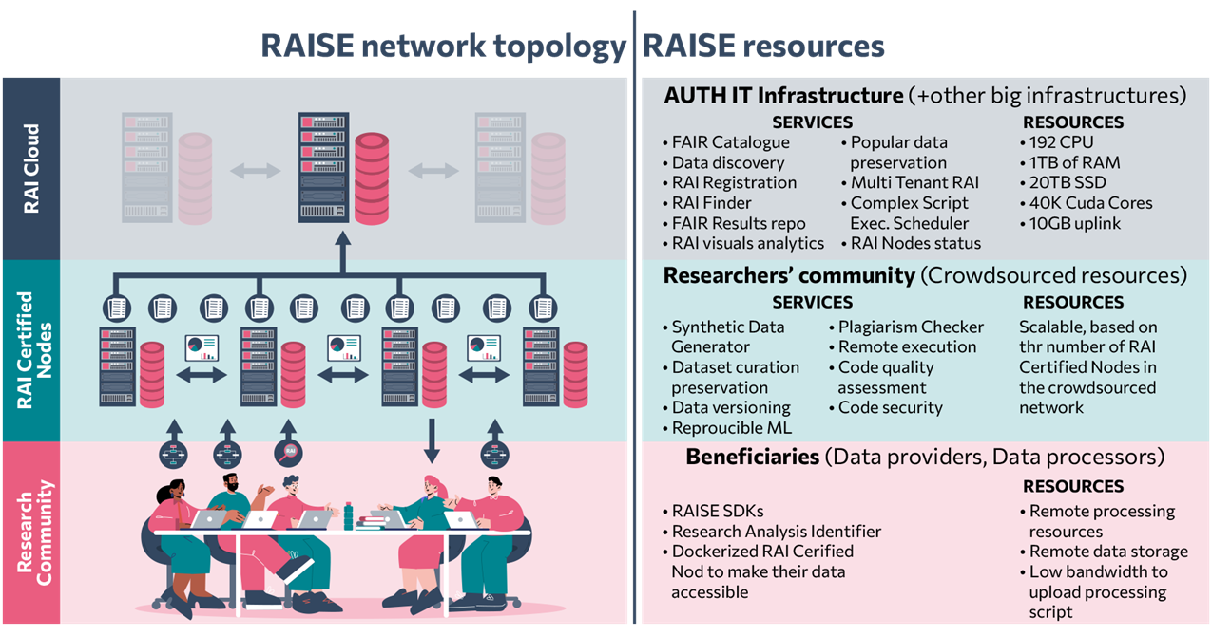
Figure 2: RAISE network topology and resources

Research Community
The research community plays a vital role in the RAISE service by fostering collaboration, knowledge exchange, and innovation among researchers, academics and professionals in various fields related to the service (health, mobility, environment and cross-disciplinary fields). The main actions that the research community, either data providers or data processors, can perform through the RCNs and RCH include the following:
- Make their data accessible in the RCNs.
- Find and request access to available datasets in the RCNs.
- Upload and run processing scripts or algorithms to the RCH.
- Get experiment results (with dataset and processing script or algorithm pair).
- Register experiment results and get a registered RAI PID.
- Find registered experiments under the RAI PID.

RAI Central Hub
The RCH is the intermediate interface of the RAISE system and the network of the distributed RCNs with the research community. Since the RCH hosts the core services of the RAISE system, it has the following functionalities.
- Offer a FAIR catalogue and portal to discover datasets, processing scripts and algorithms, and results in different RCNs.
- Request and retrieve synthetic and shareable versions of datasets hosted in any RCN.
- Request and retrieve results obtained from a remote execution of a processing script or algorithm and dataset pair from any RCN.
- Obtain, find and resolve assigned RAI PIDs to registered experiments.
- Schedule and support the execution of complex processing scripts or algorithms involving experiments combining sub-experiments over different RCNs.
- Perform code quality and security analysis on the uploaded processing scripts and algorithms.
- Implement a multi-tenant RCN for collaborators without an RCN and for popular dataset preservation.
- Monitor and track the statuses of the registered RCNs.
For the development of the RCH, multiple technologies have been used to facilitate the development of a fully operational, efficient hub that offers an interconnected broker system, enabling access to researchers to perform data operations. The technical requirements and the selected technologies for this agent are listed in Error! Reference source not found..
Table 1: Requirements and technologies of the RAI Central Hub
Functionality | Requirement | Technology
FAIR catalogue and data discovery | A web application that enables users to access and utilize all the available features of the project. | Next.js (Frontend) [1]
FAIR catalogue and data discovery | A REST API to handle all the requests from the front end. This service is also responsible to store the dataset metadata and handle all the interactions with the RAI Nodes and other RCH services. | Drupal 10 (Backend) [2]
RAI Finder | A finder and resolver service for the RAI identifier. The service will provide trustable information on the authorship, timing and identification of source datasets and algorithm, together with the resulting research outputs. Blockchain technology will be used to provide integrity to the information of the RAI identifier. Each published object will be matched with a hash key generated by the blockchain. | A relational database and ASP.NET Core framework, HyperLedger Fabric [3]
Scheduling of complex script execution | A platform to orchestrate experiments across multiple RCNs, allowing for the execution of scripts on one node and the analysis of results on another. | Apache Airflow platform [4] and Apache Nifi system [5]
Reproducible machine learning (ML) | A web service consisting of a set of APIs to interact with the Portal. The APIs provide access to the code and data versioning services and trigger the script pipelines. | Gitlab [6], Python and Flask [7]
Code maintainability and security analysis | A web service with an API to interact with the Portal and the script pipelines. | Springboot framework [8]
Code maintainability and security analysis | A containerisation technology to execute the requested calls and analysis in a controlled environment. | Docker containerization technology [9]
Code maintainability and security analysis | A task queue system to process the static/dynamic security and performance analysis requests. | RabbitMQ message broker [10]
Code maintainability and security analysis | A non-relational database storage service to archive static/dynamic security and performance analyses. | MongoDB [11]
Popular dataset preservation | An algorithm will be implemented that categorizes datasets as popular or non-popular. Datasets belonging to the popular category will be cached (with corresponding data transfer agreements) to balance RCN load and ensure datasets availability . | Custom algorithm written in Python/ NodeJS
RAI nodes status monitoring | A web service installed on the node to collect metrics for the node, the datasets and the experiments. | Python, Flask [7] and MariaDB [12]

RAI Certified Node(s)
The RCNs are distributed nodes composed of a software package that can be installed in the researcher's machines to create a crowdsourced network of nodes that are connected to the RCH. Each distributed node is responsible for data storing and processing tasks in a secure and controlled environment. An RCN is responsible for the following tasks:
- Collect, prepare, and store original datasets uploaded by the research community to the node.
- Detect plagiarism and versioning datasets.
- Generate and share synthetic and shareable dataset versions representing original datasets stored in the node.
- Remotely execute processing scripts and algorithms uploaded by the research community with the original datasets stored in the node.
- Request results registration in the RAI Cloud under the RAI PID.
The RCNs of the RAISE service have been developed in the Python programming language and using containerization (Docker) technologies with docker-compose deployment technologies for deploying each node. Table 2 gathers the requirements of the RCNs and the technologies used to fulfil each of them.
Table 2: Requirements and technologies of the RAI Certified Nodes
Functionality | Requirement | Technology
Dataset curation, preservation and storage | A web framework for building an API to interact with the node. | FastAPI python package [13]
Dataset curation, preservation and storage | Tools and packages to curate and process datasets. | Pandas [14]and numpy [15] python packages
Dataset curation, preservation and storage | A files storage server to store the datasets. | MinIO S3 object storage server [16]
Data versioning | A web service to allow the versioning of the experiment datasets. | Data Version Control (DVC) [17]
Synthetic and shareable dataset generation | A task queue system to process synthetic and shareable dataset generation requests. | RabbitMQ message broker [10] and Celery distributed task queueing system [18]
Synthetic and shareable dataset generation | Open-source and hand-made synthetic data generation models and tools | SDV python package [19], tensorflow [20], pytorch [21] and other python packages.
Synthetic and shareable dataset generation | A machine learning (ML) models tracking and registration server to keep track and log the synthetic data generation models. | MLflow platform [22]
Synthetic and shareable dataset generation | A files storage server to store the synthetic and shareable datasets. | MinIO S3 object storage server [4]
Remote execution of processing scripts and algorithms | A task queue system to process the remote execution of experiments requests. | RabbitMQ message broker [10] and Celery distributed task queueing system [18]
Remote execution of processing scripts and algorithms | A containerisation technology to execute the requested experiments in controlled and unique environments. | Docker containerization technology [9]
Remote execution of processing scripts and algorithms | A files storage server to store the processing scripts or algorithms and obtained results. | MinIO S3 object storage server [4]

RAI Registration Service
The RAI Registration Service is a registration service to store all information regarding remotely executed processing scripts. It is responsible for guaranteeing the perdurance of research analysis results in time and registering the information and research assets involved in a scientific experiment upon a request made by the research community. These assets and information will be encrypted and written into a blockchain network, producing the previously mentioned immutable RAI.
The module has been developed in NodeJS using a web-framework to implement a REST API for other module interaction and leveraging on Blockchain tools like BigchainDB and Hyperledger Fabric. Additionally, it features a non-relational database and a message broker. Table 3 gathers the requirements of the RAI Node and the technologies used to fulfil each of them.
Table 3: Requirements and technologies of the RAI Certified Nodes
Functionality | Requirement | Technology
Register, find, and resolve assigned RAI PIDs for remotely executed processing scripts results. | A web framework for providing a REST API interface for other services interaction with the module. | HAPIJS (NodeJS package) [23]
 | A messages broker to allow requests to be queued and elaborated when possible and allow failed requests to be re-elaborated later in time. | RabbitMQ message broker [10]
 | A non-relational database storage service to archive registration requests data and logs. | MongoDB [11]
 | A driver interface for interacting with the Blockchain network. | Bigchaindb driver (NodeJS package) [24]
 | A driver interface for interacting with the Fabric network. | hyperledger/fabric-gateway (NodeJS package) [25]

RAISE service architecture
This section will provide descriptions of the overall RAISE service architecture and all the modules and submodules that compose the service.

Overall RAISE service architecture
The designed architecture for the RAISE service is depicted in Figure 3. The architecture diagram shows the modules and submodules of the service and how they are connected and the interactions between them. All modules have been first independently designed and developed and then integrated in the whole architecture. Except for the three RCNs that are depicted in the diagram, the architecture can support multiple RCNs and it’s desirable to have at least an RCN per each data-managing and sharing service provider.
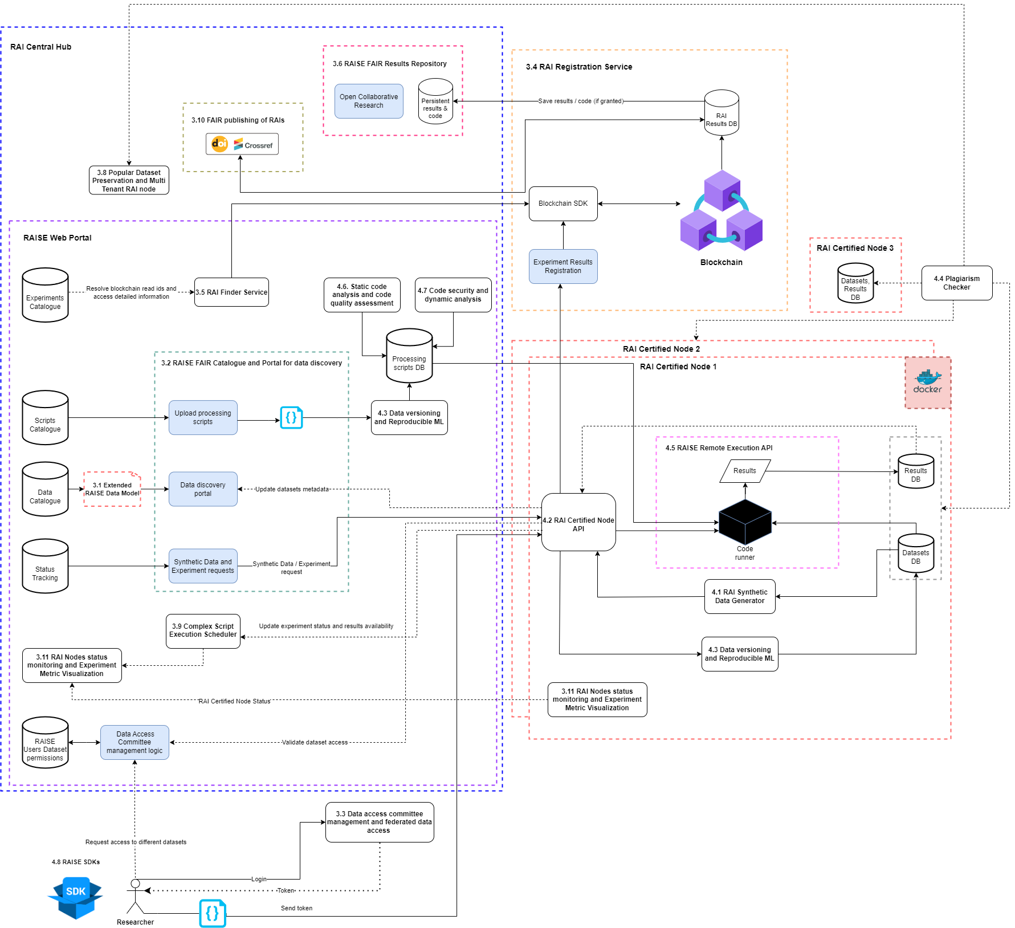
Figure 3: RAISE service architecture
As explained in section ‎1.3 the RCH is the common entry point for the research community to communicate with the rest of the modules and submodules of the RAISE service. Thus, this module communicates with the RCNs and the RAISE Registration Service (RRS) through their internal APIs. It provides (1) the data catalogue of the available data in the RCNs, (2) the processing scripts and experiments catalogue, (3) the status tracking and monitoring of tasks requested to the RCNs and the RAI finder service to explore and inspect the registered experiments under the immutable RAI. Additionally, it manages the user datasets permission through the federated authentication system.
Each RCN is installed in a controlled way in an entity using federated authentication to provide and execute tasks regarding the data storage, versioning and requests, the remote execution of processing scripts and the registration of processing scripts results with the immutable RAI. All these tasks are requested and scheduled by the research community through the RCH. Thus, this module receives requests from the RCH to execute them in a controlled environment and sends notifications to the RCH for the status tracking of the tasks. It also uses the inner API and the API of the RAI Registration Service to handle the requests that arrive to the RCN regarding the registration of results and the RAI assignment.
The RAI Registration Service is the module to store all information regarding the remotely executed analyses under the RAI. The module receives the requests for this action through the RCNs and sends notification to them when the registration requests are finished. The information registered is encrypted and written into a blockchain network. This way, the research community can make requests using the RAI Finder Service of the RCH to query all registered RAI and find information about them.
In the next subsections, each module is explained from a technical and architectural perspective to better understand each and how it works.

RAI Central Hub
The RCH is composed of different submodules that are explained in the next subsections.

RAISE fair catalogue and portal for data discovery
The Raise FAIR Catalogue and data discovery portal, serves as the central hub for all user interactions. Its main function is to help users find datasets, processing scripts, and algorithms across RAI Nodes. The portal also allows users to request and retrieve synthetic, shareable datasets and results from running processing scripts remotely. The portal architecture consists of three fundamental components, as illustrated in the figure below. This design enables fast development by separating the front end from the back end and allows the use of multiple APIs, following the microservice architecture of the RAISE project.
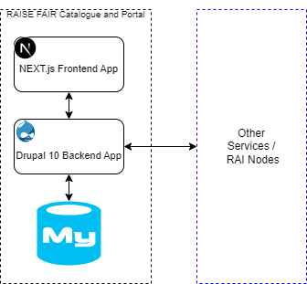
Figure 4: RAISE FAIR catalogue and portal architecture
In the next lines, it is described the communication between Portal’s components and the other services:
- The RAISE FAIR Catalogue and Portal Frontend Application is based on Next.js, a popular React framework for building web applications. To facilitate communication between the front-end and back-end components, the application uses a module called "Next.js for Drupal". The user interface of the application is designed using the Material Design system.
- The RAISE FAIR Catalogue and Portal Backend application is built using Drupal CMS, an open-source platform that is highly customizable and ideal for complex applications such as the RAISE project. The service handles user requests from the portal and serves as a middleware between the front-end and other services in the RAI Nodes or the RAI Central Hub. Moreover, it offers a search and filtering mechanism to the front-end
- The Portal Database is a MySQL database used for storing metadata about the Dataset, the user's Scripts (not actual code), just the Gitlab URL, and Experiment details along with results references.

RAI finder service
When a RAI resolution is requested via the RAI Central Hub search functionality, the RAI Finder service springs into action. By connecting to the RAI Results Database, the API retrieves the information associated with the RAI PID and delivers it back to the requester. The finder service can resolve either the PID or the hash key that was generated from the blockchain. The hash keys generated from the blocks of the blockchain, will be stored alongside the other information of the RAI PID to the RAI Results Database to safeguard the integrity of the process.

Complex script execution scheduler
The Complex script execution scheduler is a robust task scheduler for configuring, executing, and monitoring Python scripts across various RCNs with visual data pipeline representations designed with Apache Airflow [4] and Apache Nifi [5]. This module is responsible of orchestrating experiments across multiple RCNs, allowing for the execution of scripts on one node and the analysis of results on another.

Reproducible ML
The Reproducible ML module is a service to allow the streamlining of the ML lifecycle. The module will allow the experiment management (keeping track of the experiments), the reproducibility (in combination with experiment code and data versioning services) and ultimately offering a platform that simplifies the experiment processes.

Code maintainability and security analysis
For the maintainability and security analyzers, we created two RESTful Web Services and exposed their functionalities through API calls. Both services (for the static analysis) are initiated automatically when a researcher uploads a new script. The upload will trigger the creation of a GitLab repo with a pipeline, which initiates the analyzers through API call with the predefined CI_JOB_TOKEN or a newly created TOKEN. GitLab generates a unique token and makes it available to the job as the CI_JOB_TOKEN predefined variable. The token is valid only while the job is running, and after the job finishes, the token access is revoked. The CI/CD pipeline that is used can be found in the following Figure. More information about this flow can be found in Section 3.4.
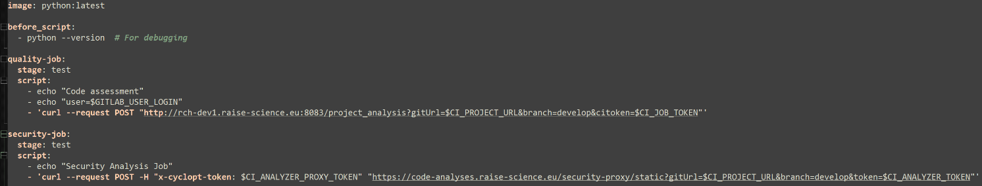 Figure 4: CI/CD pipeline

Static code analysis and code quality assessment
As already mentioned, taking into account the requirements, we have created a web service to provide the appropriate functionality. The service was created with the help of the Spring Boot framework and is developed using the programming language JAVA. Moreover, in order to provide the functionality through a controlled and isolated environment a containerisation platform Docker was used, due to its popularity and robustness. Regarding the containerisation of the application, we created a base docker image, which contains all the required third-party tools and dependencies. The Dockerfile for the creation of this image can be found in the repository of the project along with the actual code, which is in a GitLab instance of RAISE.
In more detail regarding the service, we provide two different types of assessments (and we plan to add one more). For simplicity reasons, these functionalities are part of the one service we described and not different components, but they could be considered subcomponents of the overall assessment service. These subcomponents analyse the code based on different aspects:
- Based on external tools. We integrated four existing tools for code quality analysis in order to capture the quality based on different types of assessment. The existing external tools that were used are Pylint, Pytest, Duplicate Code Detection Tool, and Pipreqs.
- Based on Technical Debt. The notion of Technical Debt has been very popular in the last decade and a lot of tools have tried to quantify it, based on the “Principal” (the effort that is required to bring a project to an “optimum” state). We should note that the calculation of “Interest” requires more research before it is developed into our solution.
- Based on quality metrics. Quality metrics have been used for many years in software development and maintainability. We will calculate a variety of metrics, but since the majority of the users might not know their meaning, an aggregation or threshold mechanism should be examined.

Code security and dynamic analysis
To further ensure the quality of researchers’ code as well as the integrity and the robustness of the RAISE infrastructure, three analyzers are being developed, a static security, a dynamic security, and a performance analyzer. The analyzers are integrated within a service that is designed with respect to scalability, adaptability and security, thereby enabling them to adapt to varying usage patterns or demands.
Figure 4 illustrates the service architecture of the three analyzers. Initially, the analyzers are activated from the RAISE Portal through events such as script uploads (static security analyzer) or experiment executions (dynamic security and performance analyzers). Subsequently, a Proxy intercepts the request, responsible for modifying it and adjusting the authorization tokens before routing it to the Server. The Server's duties encompass creating analysis entries in a MongoDB database and forwarding requests to the respective analysis Queue. These Queues, established using RabbitMQ, operate separately for each analyzer. Deployed as Workers subscribed to their respective Queue, the analyzers process the analyses, transmitting results back to the Server, which registers them in the database under unique IDs. This cycle continues as each Worker retrieves and processes the subsequent analysis from the Queue. Notably, this architecture offers rapid deployment of additional workers to accommodate increasing analysis demands, facilitating parallel processing of multiple analyses per type. Moreover, scalability is further enhanced by the potential deployment of multiple Server instances connected to a load balancer in response to substantial increases in usage requirements (if any). Consequently, the system's scalability and robustness are significantly amplified. It is however important to note that this architecture is under continuous improvement and changes to the components might occur in future RAISE deliverables.
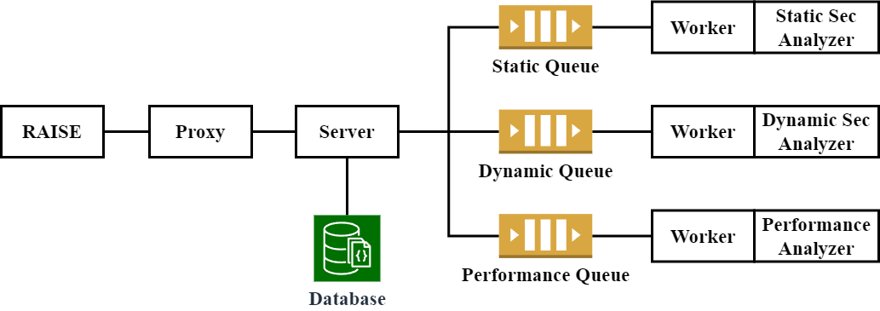
Figure 5: Static/Dynamic security and Performance analyzers’ architecture
The static security analyzer is responsible for detecting code vulnerabilities and assessing the overall security score of the code. Additionally, it provides extensive information to the users about the identified vulnerabilities and how they can be resolved. This analyzer is triggered whenever a script is uploaded to RAISE via the autogenerated CI/CD pipeline using a POST request to the respective analyzer service (via the Proxy). Following the aforementioned architecture, the analysis is processed by the analyzer and the results are stored within the database. After the completion of an analysis, the RAISE Portal is notified, and the results are retrieved to be displayed in the RAISE Portal interface.
The dynamic security and performance analyzers are activated whenever a new experiment is initiated. Their primary task is to analyze the code's behavior dynamically. The dynamic security analyzer is tasked with identifying any malicious or harmful behavior within the user's script by scrutinizing it within a secure environment. This fortifies the robustness and security of the RAISE infrastructure while mitigating the risk of system exploitation through arbitrary code execution. Conversely, the performance analyzer monitors the executed code's behavior from a performance perspective, tracking resource utilization and extracting metrics such as CPU usage, memory consumption, and disk I/O. Both analyzers adhere to the aforementioned Worker-based architecture, analyzing the script and subsequently notifying the RAISE Portal upon completion of the analyses. However, it's worth noting that the integration of the dynamic analyzers within RAISE remains an ongoing task. The workflow of the analyzers can be seen in Figure 6.
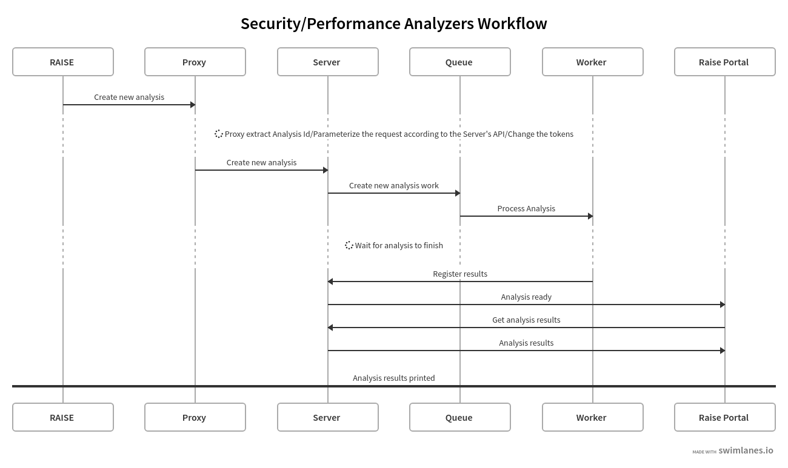
Figure 6: Static/Dynamic security and Performance analyzers’ workflow

Popular dataset preservation and multi-tenant RAI node
In the multi-tenant RAI nodes, frequently accessed datasets will be strategically preserved for rapid retrieval. Through an algorithmic assessment of usage frequency, datasets identified as popular will be cached within the nodes. Datasets that are not popular will be removed from the preservation cache. This caching mechanism aims to optimize retrieval times, ensuring efficient access to frequently requested data.

Fair publishing of RAIs and results repository
The FAIR publishing of RAIs will be implemented through the utilisation of blockchain in their creation. When a new experiment, script or dataset is uploaded in the Central Hub, the RAI Registration Service creates a new RAI PID. The PID is given a unique hash key generated by the blockchain to verify its authenticity and validity. The PID fields hold all the information needed to secure that the process is FAIR. These fields for example include the name of the author(s), the date the experiment was created and the identifying information of other datasets (if used). Once the PID is verified by the blockchain, its information will be stored in the RAI Results DB.

RAI nodes status monitoring
The RAI nodes status monitoring service consists of a web service installed on the RAI nodes, which is used to collect metrics for the datasets and the experiments. The service will monitor the usage of the node in terms of dataset size, experiment duration, reuse of results and versioning of the experiments and the datasets. The service will also collect metadata compatible with the OpenAIRE Graph [26], along with use of open/closed datasets, synthetic datasets and experiment code downloads, focusing on the metadata following the FAIR digital assets principles.

RAI Certified Node(s)
The RCN is the software package that is responsible for (1) storing the real and shareable datasets uploaded by the research community, (2) providing shareable datasets (uploaded by the research community or synthetically generated) to the research community, (3) executing processing scripts remotely with the real datasets stored internally in the module, and (4) request the obtained results to register them the assigned immutable RAI. This module, which can be installed in an extensive number of entities, has been developed following a microservice architecture design composed of six services that communicate with each other in the way depicted in Figure 7. These different services are bundled through containerisation (Docker) technologies and managed through docker-compose container orchestration technology. The selection of these technologies facilitates the deployment and update of the RCNs in different entities.
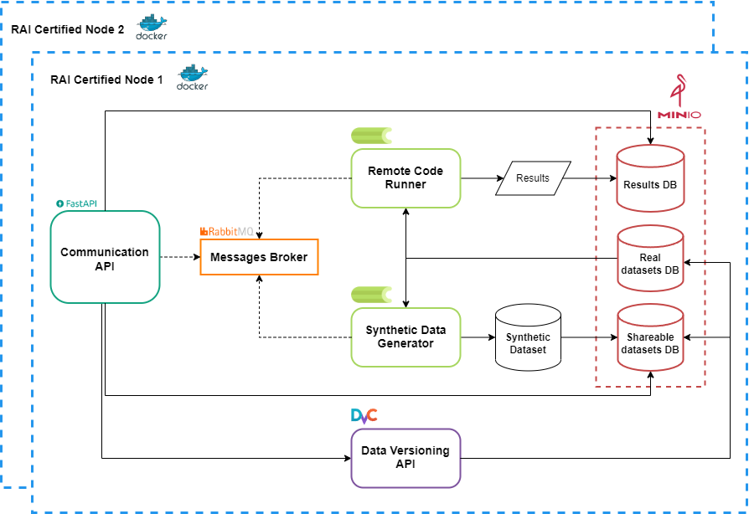
Figure 7: Architecture of the RAI Certified Node(s)
In the next lines, each service and how they communicate with each other is described:
- The Messages Broker is an open-source message broker based on RabbitMQ [10] that is used in the RCN to communicate the main services of the module and queue tasks. Specifically, this broker is used to queue and schedule synthetic data generation tasks and the remote execution of processing scripts.
- The MinIO Server is an object storage server [16] used in the RCN to store: (1) the real and shareable datasets uploaded by the research community, (2) the generated synthetic datasets, (3) the necessary files for the remote execution of processing scripts with real datasets, and (4) the results produced as part of the remote execution of processing scripts with the real datasets.
- The Communication API is an API developed in the Python programming language using the FastAPI framework [13] that handles the requests from the scientific community made by the RCH. It also works as an intermediary between the Data Versioning API, the Synthetic Data Generator, and the Remote Code Runner. Thereby, it has access to the Messages Broker (to queue tasks for the other modules), and the shareable datasets and results databases of the MinIO Server.
- The Data Versioning API is an API developed using the Python programming language and the FastAPI framework [1] that uses the DVC version control framework for the versioning and storage of the real and shareable datasets, uploaded by the research community on the RCN. This module has access to the MinIO Server to store the real and shareable datasets and handles all data upload and version requests that are triggered by the Communication API.
- The Synthetic Data Generator is a distributed system developed using Celery [18] and the Python programming language. This module is responsible for training synthetic data generation models for generating synthetic versions of the real datasets uploaded in the RCN by the research community. Thus, it has access to the Messages Broker (to see the queued tasks regarding the generation of synthetic datasets) and the MinIO server (to retrieve the real datasets and stored the synthetic datasets versions). The synthetic data generation models have been designed using the SDV python package [19], tensorflow [20], pytorch [21] and other python packages. Apart from that, the trained models are tracked and stored in a MLflow server [22].
- The Remote Code Runner is also a distributed system developed using Celery [18] and the Python programming language. This service processes and queues the tasks regarding the remote execution of processing scripts with real datasets stored in the MinIO server that are sent through the Messages Broker by the Communication API. It has access to the Message Broker (to see the queued tasks regarding the remote execution) and the MinIO Server (to retrieve real datasets, access the necessary files for the remote execution and store the obtained results). For each remote execution task received the processing script is executed in a controlled and isolated environment created exclusively for it. When the execution is completed, and the results are stored in the MinIO server the created environment is deleted.

RAI registration service
The RAI registration service is the RAISE application module responsible for (1) managing the remotely executed processing scripts data registration requests, (2) storing the results in the internal database, and (3) triggering the procedure to register them to the blockchain under the immutable RAI. Furthermore, through the previously presented RAI finder service, it allows to query the information regarding each registered immutable RAI or act like a blockchain client to read the ledger data. The module is composed of three main components, that interact with each other via REST API and RabbitMQ integration. It features a blockchain network with whom communicates and is integrated via specific drivers. Figure 8 illustrates the service internal architecture and the interaction with the blockchain network.
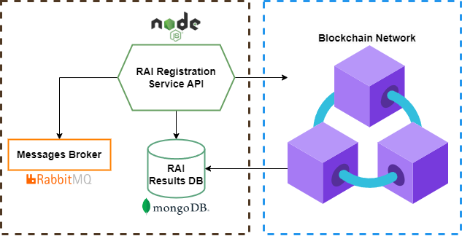
Figure 8: Architecture of the RAI registration service
In the next lines, each service and how they communicate with each other is described:
- The RAI Registration Service API is the core logic of this module. It is developed in NodeJS [27] leveraging HAPIJS to provide REST API for the interactions from the RCNs and the Blockchain Network for processing scripts results registration. Its main task is accepting requests from other services, registering the related processing script execution results data to the RAI Results Database if needed, and triggering the blockchain registration process.
- The RAI Results Database is a MongoDB service [11] used for storing blockchain resource registration requests, data assigned to immutable RAIs and logs persistence.
- The Blockchain Network is a distributed network of nodes that records data, via blocks transactions, on the distributed ledger. This network leverages blockchain technology to implement a distributed service allowing the registration of remotely executed processing scripts results under an immutable RAI. Every registration in the system generates a unique identifier that allows followingly to verify its integrity via the blockchain integration and using the RAI finder service.

Plagiarism checker
Upon the uploading of a new dataset or remote execution results computation within a RCN, an AI service will perform a check to find if there are similarities with the actual dataset. Within this service probability is produced to determine similarity, using ML, fingerprint techniques, and further research measuring specific properties of the dataset and results data. The results plagiarism check will be run (alerting responsible for high similarity) before an experiment registration request is sent to the RAI registration service.

RAISE Software Development Kit
The RAISE software development kit (SDK) has been designed to make all functionalities of the RCNs regarding the remote execution of processing scripts transparent to the research community. In the actual version of the service, the RAISE SDK provides documentation, code samples and guides to enable researchers to create processing scripts by focusing on the algorithm part rather than wasting efforts on the technical details. This SDK also make transparent the downloading of shareable datasets and uploading of datasets and processing scripts for remote execution. Currently, the remote execution of processing scripts is only compatible with the Python programming language. However, it will be extended to support more programming languages such as R, Java, C or Matlab.

Federated authentication and data access
The federated authentication module serves as a standard authentication server for all the RAISE functionalities that require a user permission check, i.e., requesting access to datasets through the RCH. On top of the RAISE service, it serves as a Single-Sign On (SSO) server, which performs the function of a firewall. A Keycloak identity and access management service [28] has been deployed for this implementation, which the OpenID Connect, OAuth 2.0, and SAM standard protocols.
When a researcher accesses any RAISE component that needs authentication, the researcher is redirected to the keycloak authentication server. After the redirection, the login process is done by keycloak, by verifying the user’s credentials. If the login is successful, keycloak generates an authenticated session and provides an access token that contains encoded information about the user. Then, the user is redirected back to the initially referred service. When a RAISE component does a remote request to another RAISE component, the latter component validates through keycloak the previously generated token to allow the request.

RAISE user use cases workflows
Current workflows design for the first four defined RAISE user use cases presented in Section ‎1.2 are explained in this section. The latter five RAISE user use cases are not presented in this section since from the start of the project until the date the manuscript was written more priority has been given to the design of these first use cases. The workflows designs have been modified and adapted to the necessity of the RAISE service. In the next subsection the designed workflows for each user use cases are explained.

Make data accessible
The availability of data is the first step for promoting open science and research. The workflow depicted in Figure 9 presents the steps that researchers can follow in order to make their datasets available, employing a secured and controlled manner. Datasets may be processed and stored in any deployed RCN via the RCH, and become available to the research community, either directly through the RAISE portal or indirectly through the OpenAIRE Graph.
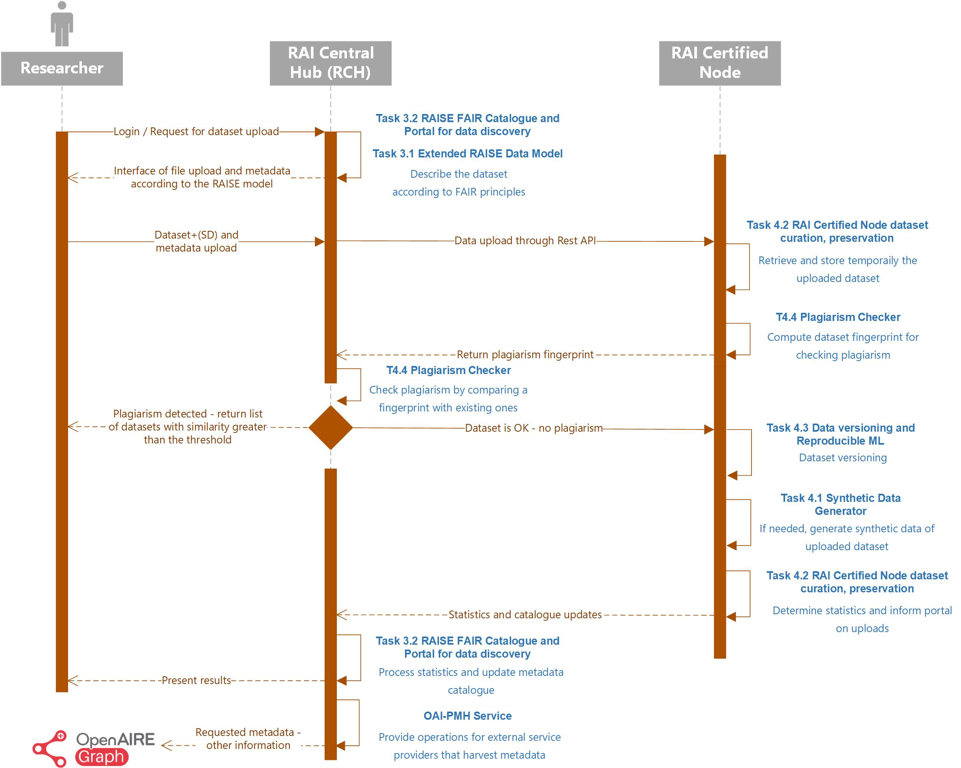
Figure 9: Defined workflow for the Make Data Accessible use case
The RAISE portal of the RCH is an intelligent Web platform that enables controlled access to the underlying functionalities of the system. After login, a researcher is presented with the main dashboard and pages for all the core assets e.g., managing his datasets. Through the corresponding form, he can upload a complete or original dataset to the registered RCN of his preference, together with a shareable version of it (i.e., shortened, anonymised or synthetic). The researcher can also fill-in the required dataset metadata, defined according to the RAISE metadata model. The latter is based on the OpenAIRE Guidelines v4.0, through utilization of the Results Scheme (results, as digital objects described by metadata, encompass properties and relationships with other entities, while also incorporating their specific attributes).
In the case that the researcher selects to upload a shareable version of his dataset, he is also required to add a document explaining the process that he followed for generating this shareable dataset. When all the required fields and files have been filled-in and selected, the RCH sends an upload data request (through the related REST API) to the RCN that the researcher has chosen to upload his dataset. At this step, the uploaded original datafile is temporally stored in the RCN, and the plagiarism checker module is initiated.
If plagiarism is detected in the uploaded dataset (utilizing e.g., the fingerprints of binary files), the researcher will receive a notification and a list of datasets with similarity greater than the specified threshold level. Simultaneously, the temporally stored dataset will be removed from the RCN. Otherwise, the original dataset and its shareable type are versioned and saved permanently in the RCN. If no shareable dataset version is provided by the researcher, the Synthetic Data Generation (SDG) engine of RAISE will be employed for creating it. The SDG engine pre-processes uploaded datasets, utilizes various data generation methods, and produces synthetic versions for different data types. Additionally, it establishes an anonymization toolkit to safeguard privacy when publishing data, leveraging open source solutions, and adapting them for use within a RAI Certified Node.
Finally, descriptive statistics of the original dataset are calculated and sent to the RCH, along with information for updating the RAISE catalogue. All these are visualised in the dataset’s dashboard of the RAISE portal. In addition, RAISE exposes its collections of datasets - metadata records through the Open Archives Initiative Protocol for Metadata Harvesting (OAI-PMH). OAI-PMH provides an application-independent interoperability framework for the harvesting and sharing of metadata (such as titles, authors, dates, and descriptions) from digital repositories. Thus, metadata become available in a machine-readable format, allowing other external systems and services, like the OpenAIRE Graph, to easily discover, retrieve, and aggregate this information.

Find datasets and get access for processing
After uploading datasets to the RCNs and making them accessible to the research community through the RAISE portal, the workflow for finding datasets and getting access to them has been defined.
Figure 10 illustrates the workflow for finding datasets, highlighting the centralized approach of the system, in which the researcher explores for available datasets and the RCH queries its database to show those fitting the criteria. Then, the basic metadata or the queried datasets is shown to the researcher.
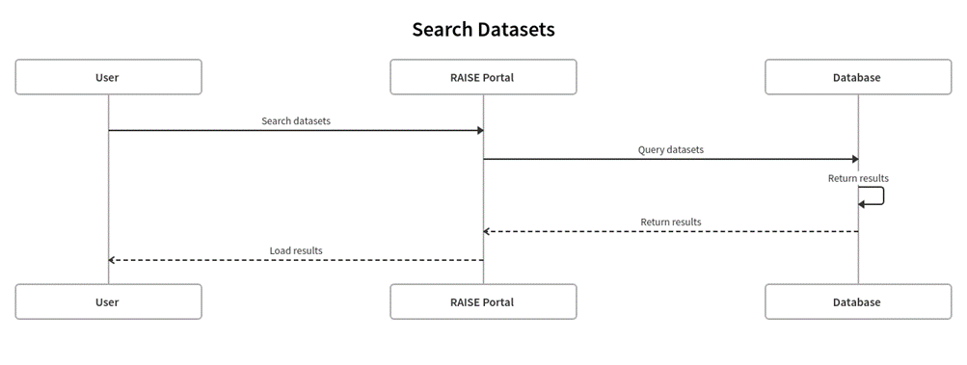
Figure 10: Defined workflow for finding available datasets
Additionally, the workflow presented in Figure 11 shows the steps for accessing dataset visualizations and statistics. First, a researcher selects the dataset that wants to explore and then, through the federated data access module, access to the dataset statistics visualization will be granted or rejected. If access is granted the researcher can see the statistics and visualizations of the requested dataset. Otherwise, a message is appeared to the researcher indicating that they do not have access to the dataset visualization and statistics.
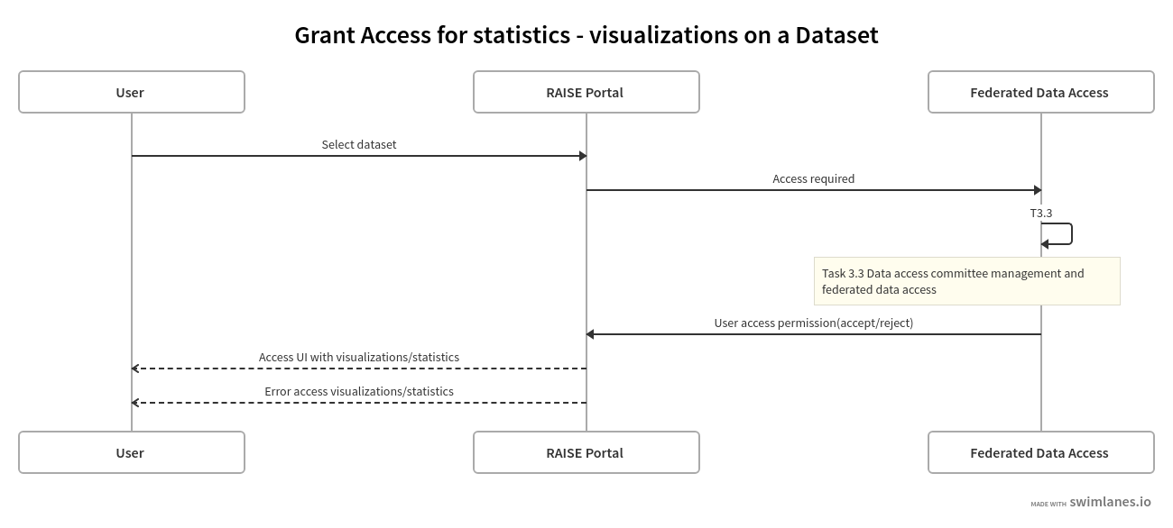
Figure 11: Defined workflow for accessing dataset visualizations and descriptive statistics

Prepare processing scripts on synthetic data
Once the researcher has found and inspected the desired datasets the workflows for retrieving a shareable dataset version to then execute and prepare processing scripts on researchers’ local machine.
Figure 12 illustrates the workflow for downloading a shareable dataset version (shortened, anonymised or synthetic) uploaded to the RCN by the researcher. First, the researcher needs to check access permission to the dataset. If dataset access is granted through the federated authentication module a request is sent from the RCH to the RCN to retrieve the requested shareable dataset. When the researcher received the shareable dataset, they can use it to prepare and run the processing script in compliance with the templates and guidelines provided in the RAISE SDK.
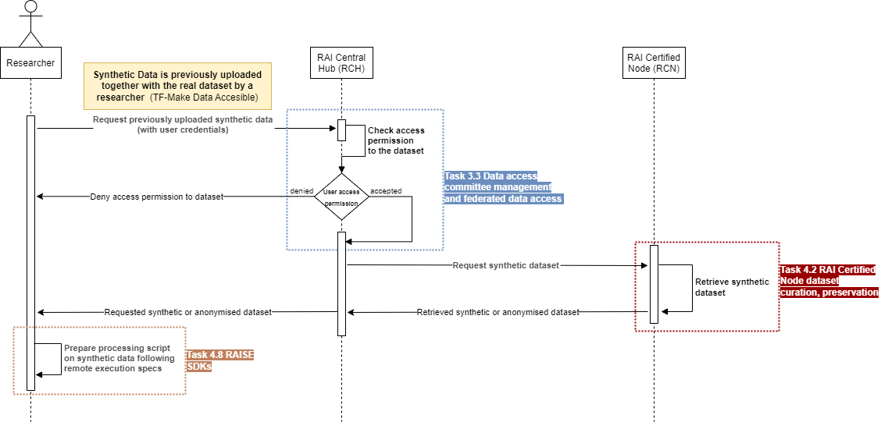
Figure 12: Defined workflow for preparing processing scripts on shareable datasets uploaded by researchers
On the other hand, Figure 13 describes the workflow for downloading a synthetic dataset version generated in the RCN by the Synthetic Data Generator module. The workflow is quite similar as the one explained above. However, in this workflow, a synthetic dataset version and some data quality evaluation metrics are provided to the researcher. In this point, the researcher can inspect the data quality metrics and make another dataset request if not happy with the retrieved data. Finally, the researcher can use the synthetic dataset to prepare and run the processing script in compliance with the templates and guidelines provided in the RAISE SDK.
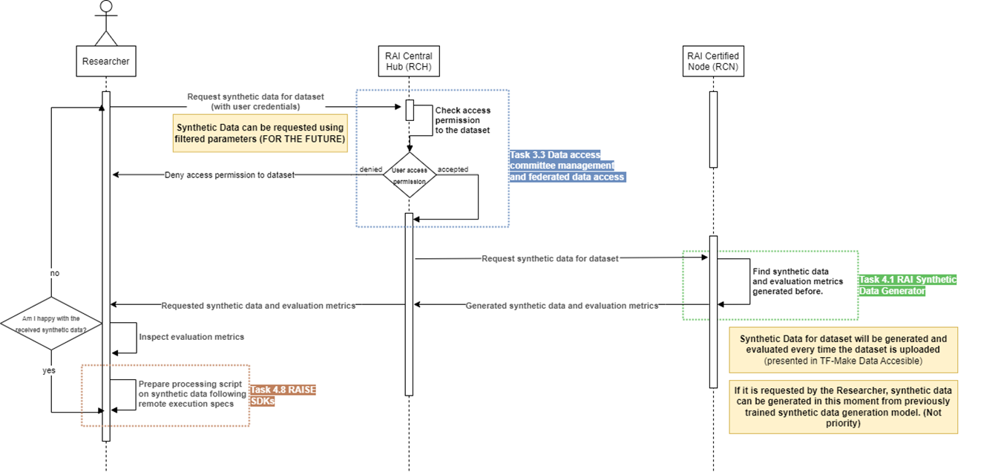
Figure 13: Defined workflow for preparing processing scripts on synthetic datasets generated by the RCN

Upload and remotely run processing scripts
The following two Figures show the workflow for uploading and running remotely (with real datasets) previously prepared processing scripts on shareable dataset versions. When the researchers want to upload a script, they should provide the files of their project to the Portal of the RAISE system. This will initiate the Script Upload component, which is responsible for creating a repository and setting up the project with the appropriate files, and CI/CD pipeline. When the commit of the files is made to the GitLab repository the CI/CD pipeline triggers the Quality Analyzer and Security Analyzer components. Since the results can be reviewed later from the Portal, there is no need to wait for the analysers to finish and the researcher doesn’t have to wait if is not needed.
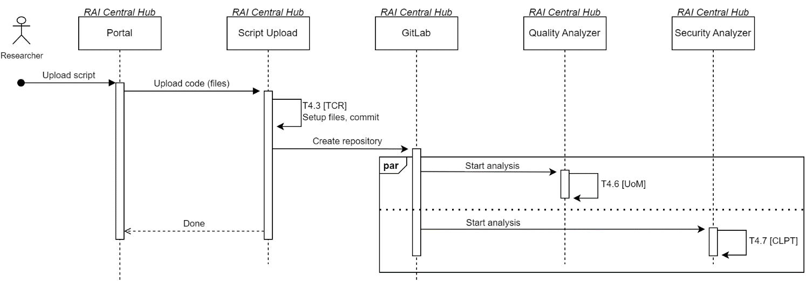
Figure 14: Defined workflow for uploading processing scripts
For the remote execution, the RCH requests the RCN for the remote execution of the processing script with a real dataset. Finally, the Remote Code Runner of the RCN executes the processing scripts in a controlled and isolated environment created exclusively for it. When the remote execution has finished, and the results are available a results registration request is sent to the RAI registration service. As soon as the last module receives the request, the results are registered with an immutable RAI in the blockchain network.
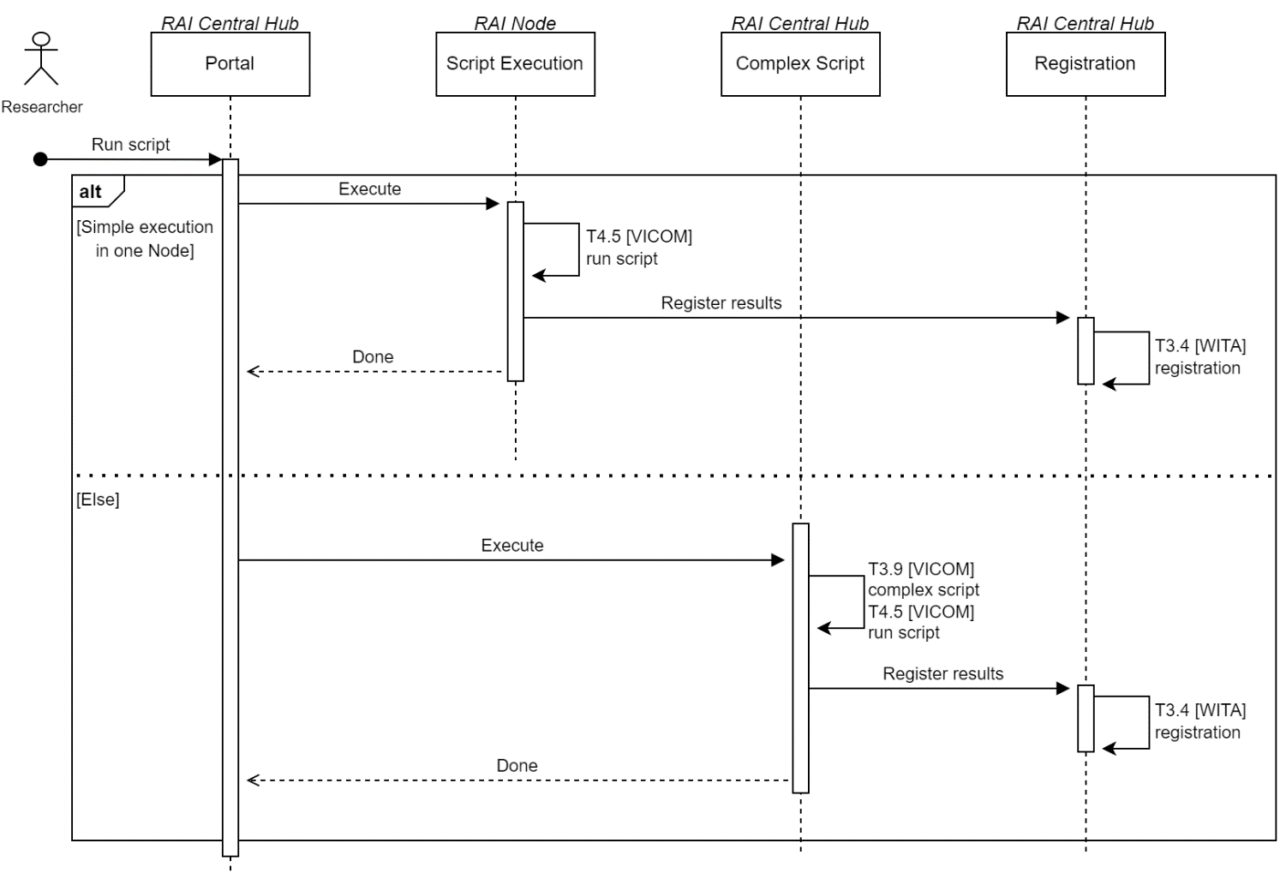
Figure 15: Defined workflow for running processing scripts

Prototype development and deployment
Current development of the actual prototype for the RAISE service will be explained in this section. From the start of the project until the date the manuscript was written, a first prototype has been fully developed and tested with some limitations.
The actual developed and deployed prototype covers the four user use cases explained in Section ‎3. Following the workflows presented above, the research community can use the RAISE portal (accessible in https://portal.raise-science.eu/) for (1) uploading datasets with or without shareable datasets versions to any available RCN, (2) find and download shareable versions of uploaded datasets, (3) prepare processing scripts locally with the shareable dataset versions and (4) upload and remotely run processing scripts with original datasets stored in the RCNs. Currently, three RCNs are deployed and registered in the RAISE portal.
In the next subsections the specifications of the deployed three RCNs are explained and then the limitations of the actual prototype and future work for next prototypes are presented.

Deployed RAI Certified Nodes
As explained above, in the current prototype of the RAISE service three RCNs are deployed and registered in the RAISE portal. These three nodes can be used form the RAISE portal to store datasets and run processing scripts remotely in each one. The three dedicated RCNs were implemented at the premises of VICOM, AUTH and UOWM to become integral parts of the RAISE service. Next, the specifications of each node are detailed.

RAI Certified Node deployed in VICOM
The dedicated RCN implemented at the premises of VICOM is deployed in a virtual machine created in a cloud server with the following configuration:
- CPU: 2 x ICX 5318Y 2P providing 24 Cores / 32 Threads
- RAM: 4 x 64 GB (DDR4-3200 2Rx4 LP (16Gb) ECC RDIMM)
- GPU: NVIDIA A16 64GB GDDR6 PCIe 4.0- Passive Cooling, w/o CEC
- SSD: 2 x 480 GB (SamsungPM893 480GB SATA 6Gb/s V6 2.5" 7mm 1DWPD 5YR SED) and 8 x 3.84TB (Samsung PM883 3.84TB SATA 6Gb/s V4 TLC 2.5” 7mm)
- OS: Ubuntu Server 22.04 LTS with Kernel 6.2
- Docker version: 24.0.7
The RCN of VICOM is the main node that is being used for both development and testing purposes for the integration of the RCNs with the RCH and RAI registration service. It supports and monitors all the current services of RAISE, managed through docker container orchestration technology. This node is accessible at https://rcn.vicomtech.org/.

RAI Certified Node deployed in UOWM
The dedicated RCN implemented at the premises of UOWM consists of a workstation with the following configuration:
- CPU: i9-13900K providing 24 Cores / 32 Threads
- RAM: 64 GB
- GPU: Nvidia RTX A4000
- SSD: 2TB NVMe (in RAID configuration)
- OS: Ubuntu Server 22.04 LTS with Kernel 6.2
- Docker version: 24.0.7
The RCN is used both for development and production services. It is deployed at the modern infrastructures of the Department of Electrical and Computer Engineering, and has access to high-bandwidth and secure internet connectivity (1Gbit) through the Greek Research and Technology Network (GRNET).
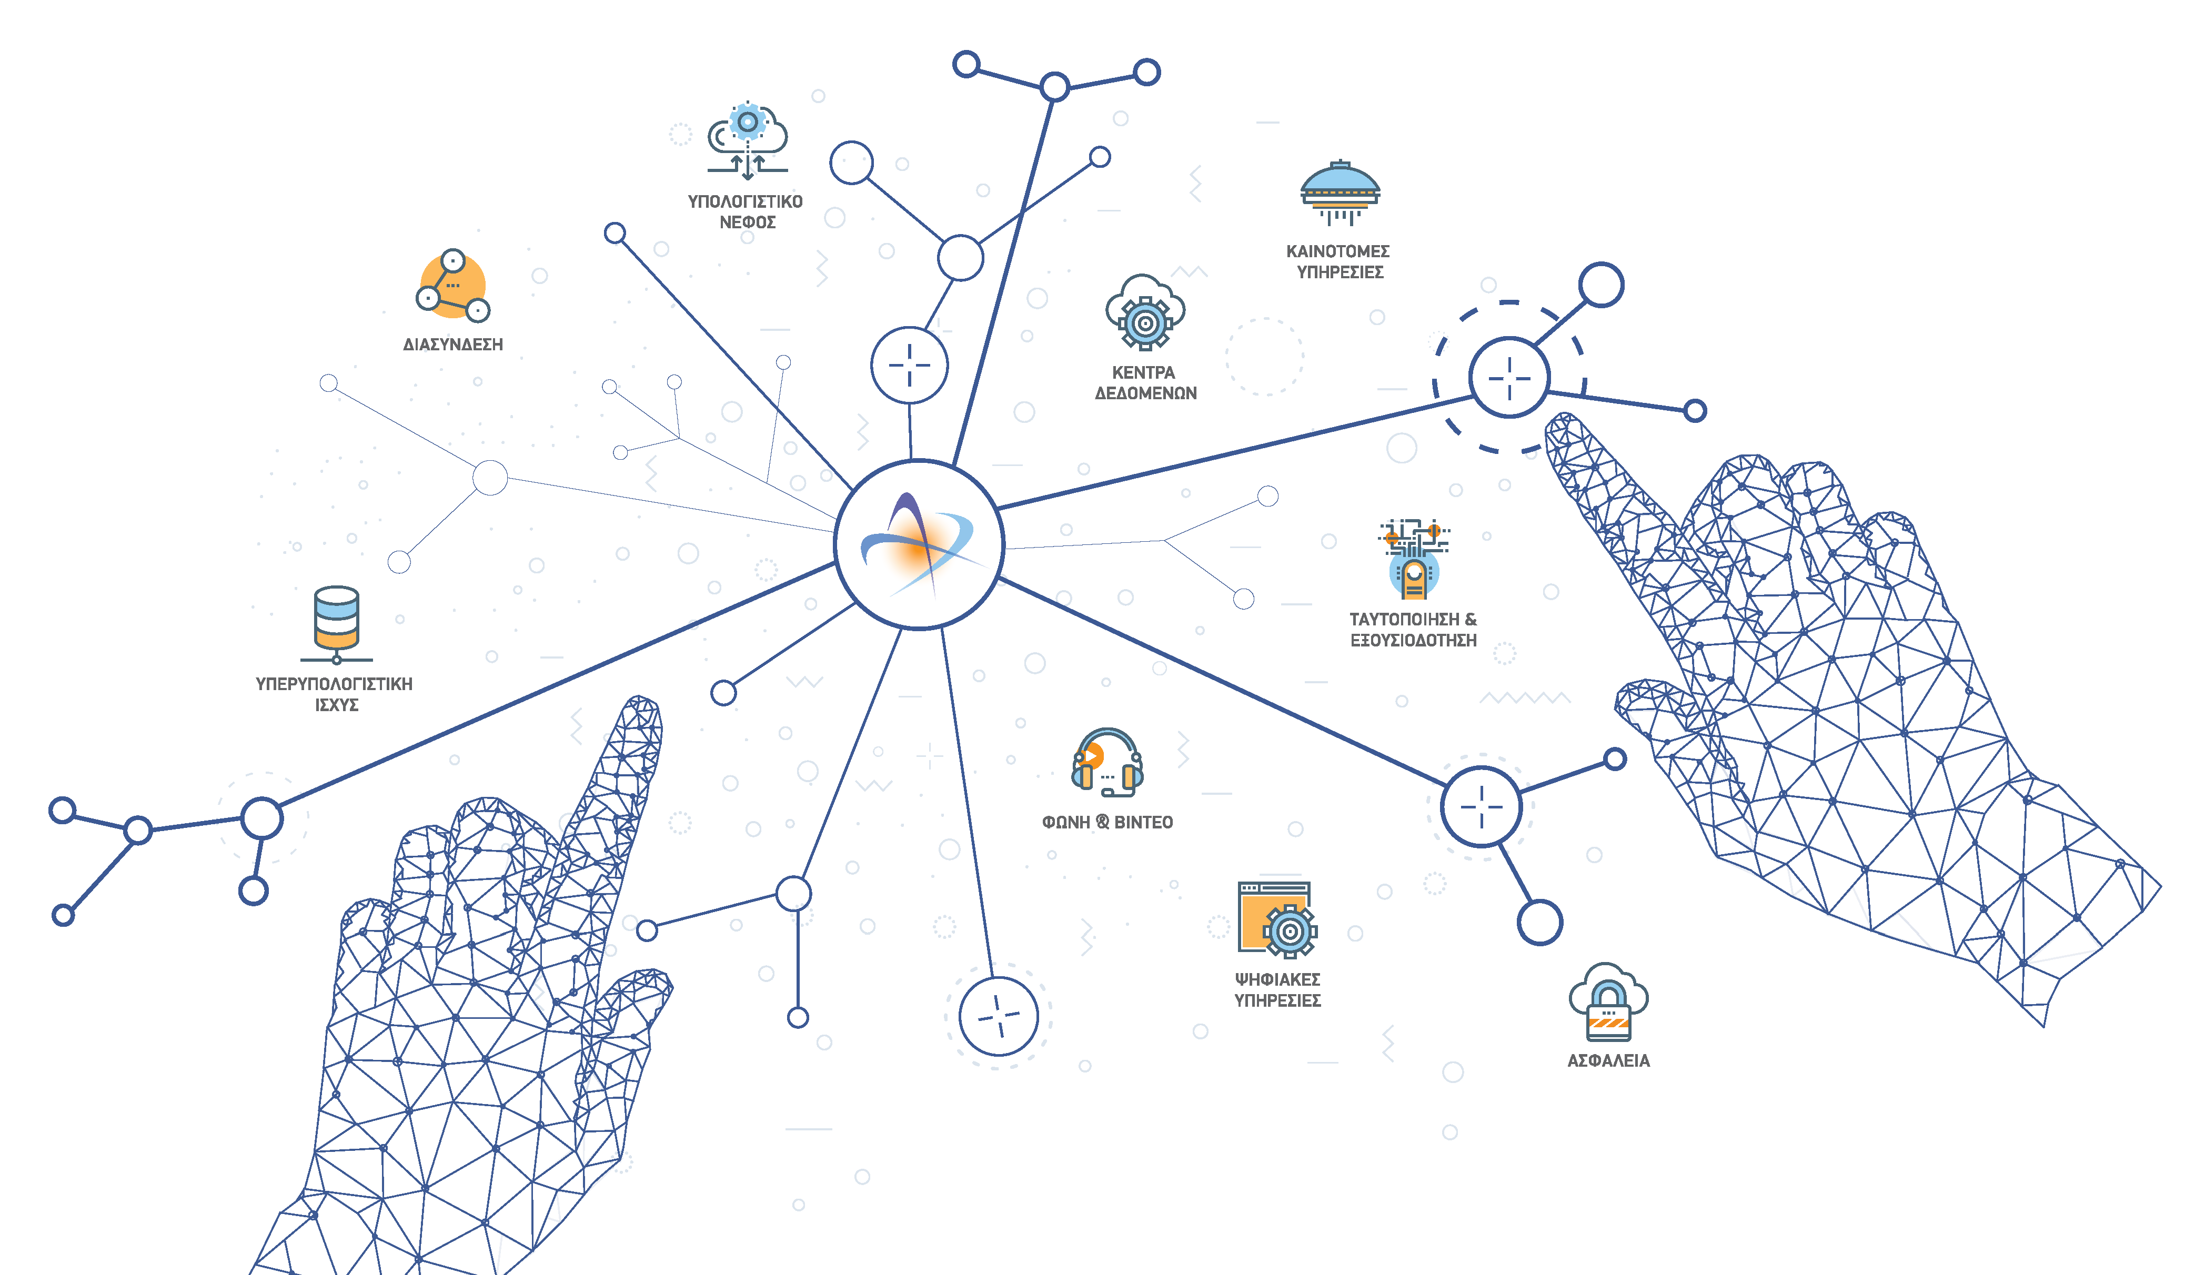
Figure 16: Services of the GRNET
The RCN at UOWM supports all the current services of RAISE, managed through docker container orchestration technology. It is integrated with the RCH and RAI registration service and it is accessible at https://raicn.ithaca.ece.uowm.gr/.

RAI Certified Node deployed in AUTH
The RCN for the RCH is based on a pair of hybrid storage systems, highly efficient, reliable and scalable. Each of the two hybrid storage systems are comprise of:
- Dual controller
- RAM: 128GB per controller
- SSD: NVMe SSD storage: >=6 disks, >= 20TB aggregate raw capacity
- HDD storage: >= 6 disks, >= 80TB aggregate raw capacity
- Triple parity RAID protection for all disks
- NAS protocols: NFSv3, NFSv4, SMB3
- Active-Active always mirroring with remote paired storage
- x 10G Ethernet per controller (8 x 10G per hybrid storage system)
- 4 x SAS3.0 interfaces per controller (8 x SAS3 interfaces per hybrid storage system)
- 2 x 100Gbps NVMe interfaces per controller (4 x 100Gbps per hybrid storage system)
- Free NVMe disk bays >=19
- Free 3.5'' disk bays >=64
- Expandable upto 300 3.5'' HDD disks, with additional shelves
- Expandable upto 50 3.5'' HDD disks, with additional shelves
- Compression, encryption, deduplication
The RCN at AUTH supports all the current services of RAISE, managed through docker container orchestration technology. It is integrated with the RCH and RAI registration service and it is accessible at https://rcn-dev1.raise-science.eu/.

Limitations of the actual prototype and future prototypes
In the actual prototype of the RAISE service, the basic actions, and workflows for the first four user use cases have been implemented and are available for the research community. This section presents the limitations of the current prototype and next actions and functionalities that are being implemented or are intended to be included in future prototypes.
With the current implementation, only datasets in CSV with specific format can only be uploaded to the node. For future implementations, the system will be compatible for more datasets that are being created in WP5 for different pilots (health, mobility, and environment). Apart from that, descriptive statistics are not shown in the portal when inspecting datasets. Currently a statistics data model is being designed to show these statistics in the RAISE portal. Those will help the research community to make a better idea of the content of the datasets.
Regarding the remote execution of scripts, only scripts in Python 3.8 programming languages following a specific syntax defined in the RAISE SDK are supported. Future work includes the support of more programming languages, such as Java, Matlab or C. Additionally, there is no limit time for a remote execution of processing scripts, which may lead to system collapse. To solve this problem, a maximum execution time will be added to the RCNs and if processing scripts execution exceed this time, no results will be obtained neither registered for the processing script. In line with that, the results size that can be obtained from a processing script are limited to a certain number of characters just to make more robust and agile the registration of processing script results under the immutable RAI.
Finally, regarding the deployment of new RAI Certified Nodes, we plan to introduce one more in the premises of UoM. The specification of this Node is going to be the following: AMD Ryzen Threadripper 1950X 16 cores, 64 GB RAM, 2 x 4TB HDD (in RAID 1 configuration), Nvidia RTX 4080.

Conclusion
This document, which corresponds to D3.1 RAISE Cloud services’ specifications and is of report nature, describe the RAISE service specification and federated architecture designed to facilitate the communication and delivery of the ICT tools developed in WP3 and WP4 that compose the RAISE system.
This deliverable presents the requirements, the designed architecture and currently implemented solutions of the RAISE service. The primary goal of this service is to effectively share and manage data across RAI nodes during experiment processing while adhering to privacy, ethics and IPR legislation and policies established by the respective research entities providing processing infrastructure. Four service agents have been defined in the RAISE service: research community, RCH, RCNs and RAI registration service.
The document starts by introducing the RAISE service, the user use cases of the service, a brief description of the agents and that compose the service and the technical requirements of them (Section ‎1). Next, the overall architecture is depicted, and each of the modules and submodules that compose the architecture are described from a technical and architectural perspective (Section ‎2). Then, the workflows designed for some of the RAISE user use cases are detailed (Section ‎3). Finally, the technical development of the service is updated, explaining the developed and deployed prototype with its limitations and drawing next action items for future prototypes (Section ‎4).

References
[1] ‘Next.js by Vercel - The React Framework’. Accessed: Feb. 28, 2024. [Online]. Available: https://nextjs.org/
[2] ‘Drupal 10’, Drupal.org. Accessed: Feb. 28, 2024. [Online]. Available: https://www.drupal.org/about/10
[3] ‘ASP.NET Core | Open-source web framework for .NET’, Microsoft. Accessed: Mar. 26, 2024. [Online]. Available: https://dotnet.microsoft.com/en-us/apps/aspnet
[4] ‘Home’, Apache Airflow. Accessed: Feb. 21, 2024. [Online]. Available: https://airflow.apache.org/
[5] ‘Apache NiFi’, Apache NiFi. Accessed: Feb. 21, 2024. [Online]. Available: https://nifi.apache.org/
[6] ‘The most-comprehensive AI-powered DevSecOps platform | GitLab’. Accessed: Feb. 28, 2024. [Online]. Available: https://about.gitlab.com/
[7] ‘Welcome to Flask — Flask Documentation (3.0.x)’. Accessed: Feb. 28, 2024. [Online]. Available: https://flask.palletsprojects.com/en/3.0.x/
[8] ‘Spring Boot’, Spring Boot. Accessed: Feb. 26, 2024. [Online]. Available: https://spring.io/projects/spring-boot
[9] ‘Docker: Accelerated Container Application Development’. Accessed: Feb. 15, 2024. [Online]. Available: https://www.docker.com/
[10] ‘RabbitMQ: easy to use, flexible messaging and streaming — RabbitMQ’. Accessed: Sep. 07, 2023. [Online]. Available: https://www.rabbitmq.com/
[11] ‘MongoDB: The Data Platform for Applications’, MongoDB. Accessed: Sep. 07, 2023. [Online]. Available: https://www.mongodb.com
[12] ‘MariaDB Foundation - MariaDB.org’. Accessed: Feb. 28, 2024. [Online]. Available: https://mariadb.org/
[13] ‘FastAPI’. Accessed: Sep. 07, 2023. [Online]. Available: https://fastapi.tiangolo.com/
[14] ‘pandas - Python Data Analysis Library’. Accessed: Feb. 15, 2024. [Online]. Available: https://pandas.pydata.org/
[15] ‘NumPy’. Accessed: Feb. 15, 2024. [Online]. Available: https://numpy.org/
[16] M. Inc, ‘MinIO | High Performance, Kubernetes Native Object Storage’, MinIO. Accessed: Sep. 07, 2023. [Online]. Available: https://min.io
[17] ‘Data Version Control · DVC’, Data Version Control · DVC. Accessed: Feb. 28, 2024. [Online]. Available: https://dvc.org/
[18] ‘Celery - Distributed Task Queue — Celery 5.3.4 documentation’. Accessed: Sep. 07, 2023. [Online]. Available: https://docs.celeryq.dev/en/stable/
[19] ‘The Synthetic Data Vault. Put synthetic data to work!’ Accessed: Jun. 13, 2023. [Online]. Available: https://sdv.dev/
[20] ‘TensorFlow’. Accessed: Feb. 15, 2024. [Online]. Available: https://www.tensorflow.org/?hl=es-419
[21] ‘PyTorch’. Accessed: Feb. 15, 2024. [Online]. Available: https://pytorch.org/
[22] ‘MLflow | MLflow’. Accessed: Feb. 15, 2024. [Online]. Available: https://your-docusaurus-site.example.com/
[23] ‘hapi.dev’, hapi.dev. Accessed: Feb. 20, 2024. [Online]. Available: https://hapi.dev/
[24] ‘bigchaindb-driver - npm’. Accessed: Feb. 20, 2024. [Online]. Available: https://www.npmjs.com/package/bigchaindb-driver
[25] ‘@hyperledger/fabric-gateway’, npm. Accessed: Feb. 20, 2024. [Online]. Available: https://www.npmjs.com/package/@hyperledger/fabric-gateway
[26] ‘OpenAIRE Graph - Home’. Accessed: Feb. 28, 2024. [Online]. Available: https://graph.openaire.eu/
[27] ‘Node.js’. Accessed: Feb. 19, 2024. [Online]. Available: https://nodejs.org/en
[28] ‘Keycloak’. Accessed: Feb. 20, 2024. [Online]. Available: https://www.keycloak.org/

https://hub.docker.com/repository/docker/nikosnikolaidis/raise-base-image
https://repo.raise-science.eu/raise_dev/rai-central-hub/quality-python-code-evaluator
https://pylint.pycqa.org/en/latest/
https://pytest-cov.readthedocs.io/en/latest/readme.html
https://github.com/platisd/duplicate-code-detection-tool
https://pypi.org/project/pipreqs/

